Justin Fan, Fengwei Zhang, Vikas Advani Navani

Project 3 phase 1

We are looking at a project which involves Gaze Behavior Monitoring System. Specific requirements have been given from the professor. In this we can clearly see in phase 1 we are required to have specific sensor requirements specifically with the characteristics it shows and how it does its processing.

The mobile device gets gaze data at every clock cycle. (x,y). x and y range from 0 to 1023. Clock is 0.01s. Regarding the image specification, they have been provided to us so that our code takes the required specifications into account and displays its output accordingly making sure all those specifications are fulfilled.

We are given lower left coordinate and upper right coordinate of regions of interest (ROI). Based on the given gaze data, we determine whether it is in an ROI. If the data is in an ROI, a tuple is generated. A tuple is structured as follows: (ROI index, start time, end time). Tracking how long the gaze was on an ROI. Once 20 tuples have been generated, the data is packetized and sent to the server

There is a handshake between the server and sensor in order for the packet to be transferred. The sensor checks if the network is busy. If it is, a random time is waited and network is checked again. Once the network is not busy, it checks if a packet can be sent to server. If no, wait random time, if yes, transfer data.

For server, we will be waiting until a sensor makes its request, then checks who made the request. Sending back its network status. If it is ok, then we are setting the network busy and transferring data.

In conclusion we will be working on a greater specification in the second phase in order of completion of the fully working project. Data was not actually transferred in this simulation because the tuple and packet data structures were not working.

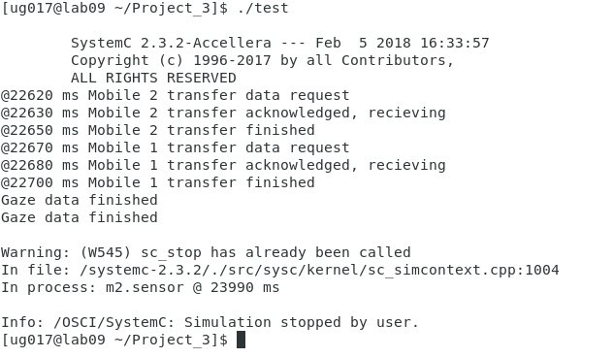

The simulation generates the output shown above. The simulation also outputs the counter data to a file so that it can be plotted. The resulting graph is shown below.

